National Bible College & Seminary

“Training men and women…
…as if souls depend on it”

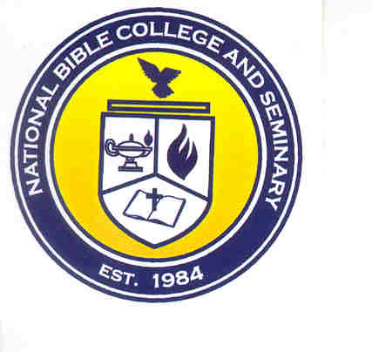

LIFE EXPERIENCE PACKAGE
2010

The Life Experience Package is to provide the student the opportunity to obtain credit in undergraduate classes for practical ministry. Life Experience includes the following ministry activities: classes taught, sermons preached, seminars conducted, weddings/funerals officiated, seminars or conferences attended, and ministries served. Research conducted for any of these activities will be calculated in the Research Materials portion.

Students can earn 3 credit hours for every 100 hours of service. A student may receive a maximum of 15 credit hours for Life Experience. Below is the credit scale, which will be used to award credit hours:

15 credit hours – 500 total hours
12 credit hours – 400-499 total hours
9 credit hours – 300-399 total hours
6 credit hours – 200-299 total hours
3 credit hours – 100-199 total hours

Note: All credit hours awarded will be subject to the current credit hour rate and must be paid within 12 months of the Award Date.

Students must provide supporting documentation identifying hours of service. All supporting documentation is subject to review and approval. Supporting Documentation include:
- Certificates
- Awards
- Sermon Outlines/Notes
- Wedding/Funeral programs
- Service Programs
- Diplomas
- Conference Registrations
- Handouts / Lesson Plans
- Letter of Verification of Service
Note: Students should not submit originals.

Students are to submit their package in a 3-ring binder. There should be four (4) clearly identified sections: Submission Form, Hours of Service Form, Resume, and Supporting Documentation.
Life Experience Submission Form

Submission Checklist:
____ Life Experience Submission Form
____ Life Experience Hours of Service Forms
____ Current Ministry Related Resume
____ Supporting Documentation
____ $15.00 payment payable to National Bible College and Seminary (Submit payment to the Accounting Office)

Title (Circle One): Mr. Mrs. Ms. Rev. Other:
Name: ________________________________________________________________
Address: ______________________________________________________________
______________________________________________________________________
Home Phone: ______________________ Work Phone: _____________________
Email Address: _________________________________________________________
Degree Program: _______________________________________________________

Affirmation: I affirm that all hours and documentation provided are true and accurate to the best of my knowledge. I understand that I have a maximum of twelve (12) months after the Award Date to complete payment for the credit hours received through Life Experience.

________________________________________ ___________________
Student’s Signature Date
Life Experience Hours of Service

Input the total number of hours on the line next to the ministry area for which you have included supporting documentation. The student will receive one (1) hour for each book listed in the Research Materials section.

Service

____ Practical Theology: Weddings/ Funerals, Ministries such as Youth, Women, Men, Seniors, Nursing Home, Prison, Music

Classes/Sermons/Seminars/Conferences

____ Christian Counseling
____ Christian Education
____ Evangelism/Missions
____ History
____ New Testament
____ Old Testament
____ Systematic Theology
____ Theology

Research Materials (Maximum of 50 credit hours)

____ Total Number of Books Listed
Note: The following forms and summaries must be typed on separate pages.

Research Materials Form
In a table similar to the one shown below, list any books (maximum of 50) used to prepare for the classes, sermons, seminars, etc that have been included in this package. (Maximum of 50 credit hours)

AUTHOR | TITLE | DATE READ | NUMBER OF PAGES READ | EVENT RESEARCH WAS CONDUCTED FOR

Conferences Attended Summary
In the format shown below, list any conferences attended.

Dates: ______________

Length of session(s) in hours: ___________

Title: _________________________________________________________________

Description: ___________________________________________________________

______________________________________________________________________

______________________________________________________________________

______________________________________________________________________

______________________________________________________________________

Seminars Attended Summary

In the format shown below, list any seminars attended.

Dates: ______________

Length of session(s) in hours: ___________

Title: _________________________________________________________________

Description: ____________________________________________________________

______________________________________________________________________

______________________________________________________________________

______________________________________________________________________

______________________________________________________________________

Seminars Conducted Summary

In the format shown below, list any seminars conducted. Only include the actual amount of time your session was conducted.

Dates: ______________

Length of session(s) in hours: ___________

Title: _________________________________________________________________

Description: ____________________________________________________________

______________________________________________________________________

_____________________________________________________________________

______________________________________________________________________

______________________________________________________________________

