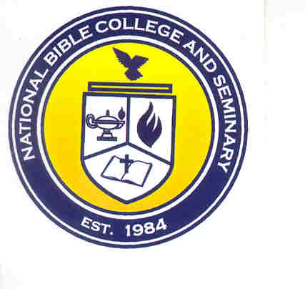
National Bible College and Seminary

6700 Bock Road

Fort Washington, Maryland 20744

Phone: 301-567-9503

Fax: 301-839-7520

GRACE SCHOLARSHIP FUND

APPLICATION

Date: __________

Name: _________________________________ Student ID#: ________________________

Semester: _______________ Year: __________

Student Classification: Senior Junior Sophomore Freshman

Scholarship applying for:

Essay Scholarship ____

Community Service Scholarship ____

Dean’s List Scholarship ____

Reason for Applying:
____________________________________________________________________________________________________________________________________________________________

____________________________________
Student's Signature

NBC&S USE ONLY
Date:

Student G.P.A: ________ Student in Good Standing YES or NO
Student Entry Date: __________ Previous Scholarship YES or NO

Approved/Denied : Reason
______________________________________________________________________________________________________________________________________________________________________

Denied:______
______________________________________________________________________________________________________________________________________________________________________

___

_____ Credit Amount to Student’s Account: _________

NBCS FORM-112 9/09

